AWS Task-2

Set up a VPC with an Internet gateway, create a public subnet with 256 IP addresses, a private subnet with 256 IP addresses, make a route table connecting the Internet gateway and the subnets, and launch a Linux EC2 instance by using the above VPC and public subnet.

Created test-vpc with the CIDR 10.10.0.0/16
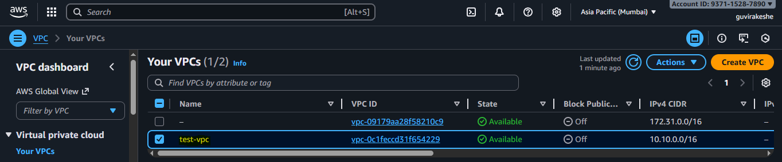
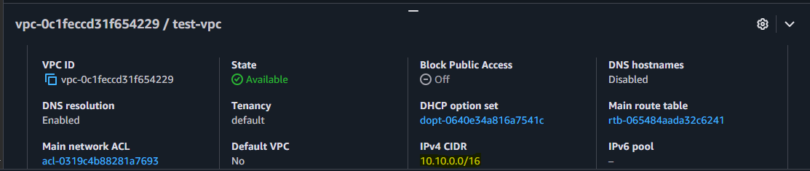

Created the IGW and attached the test-vpc.
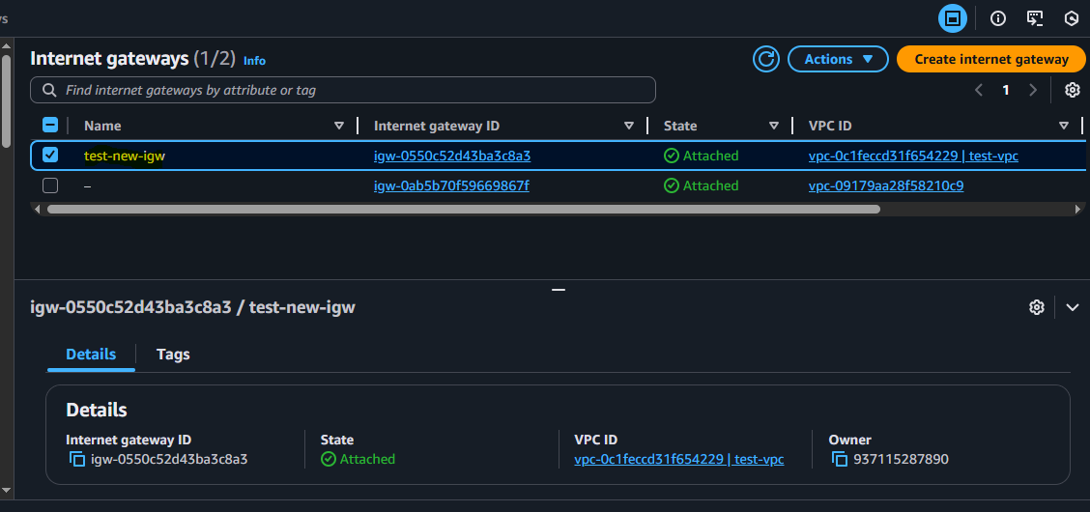

Created the public subnet(test-public-subnet-1a) with 256 IP
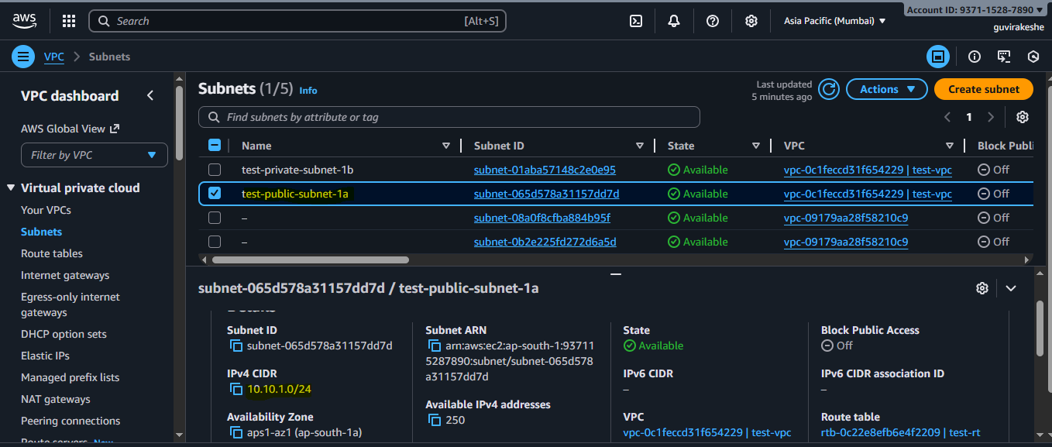

Created the private subnet(test-private-subnet-1b) with 256 IP
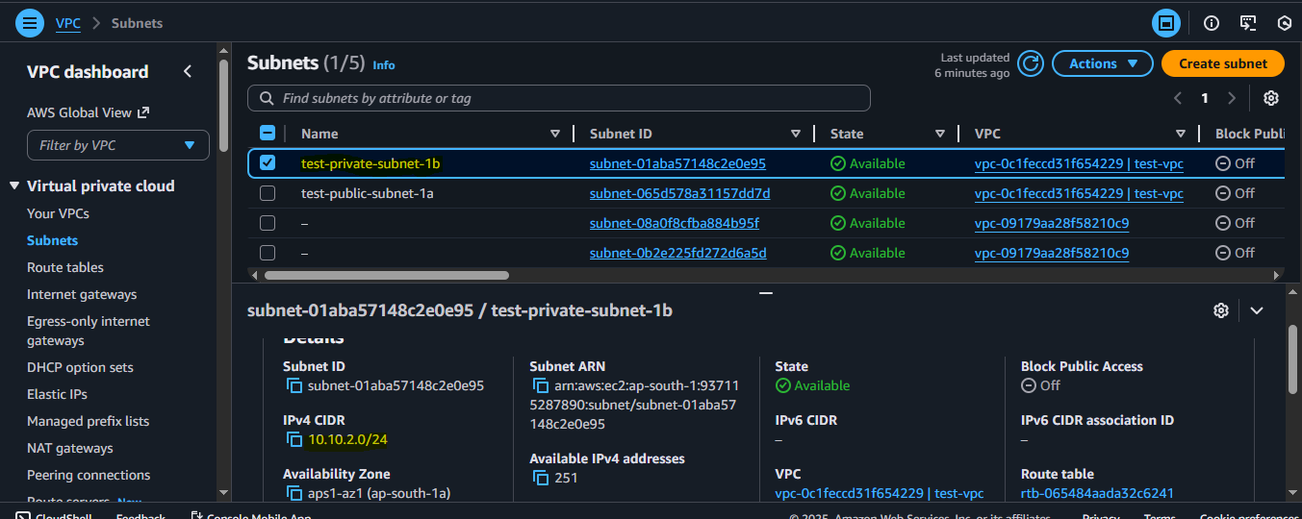

Created the route table- test-rt.
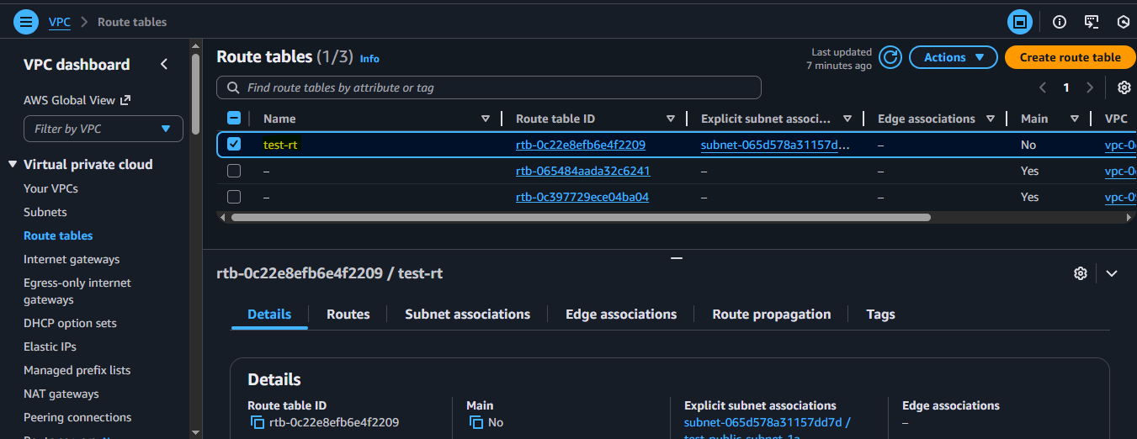
Attached the public subnet to the route table.
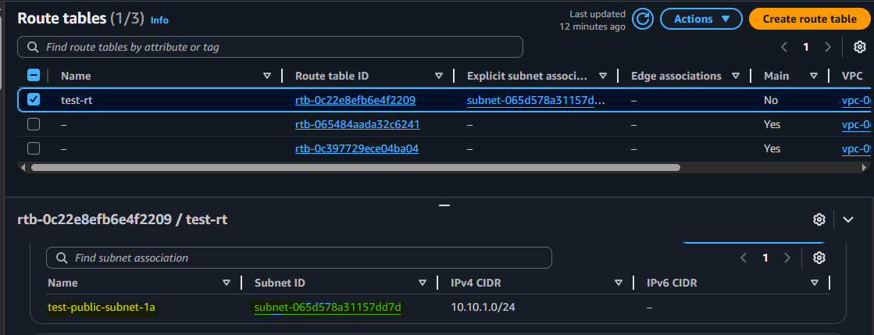
IGW attached to the public subnet.
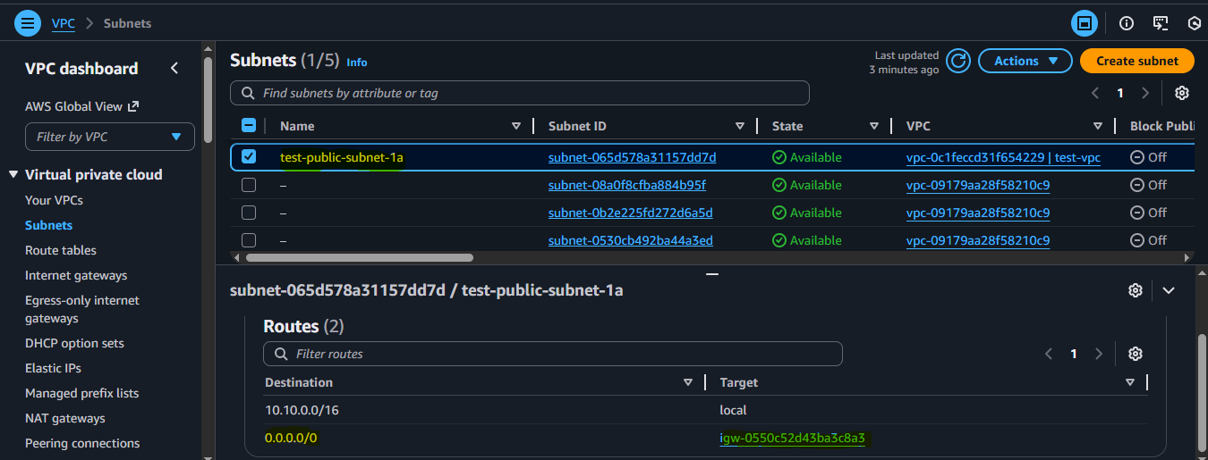

Launch the public EC2 instance
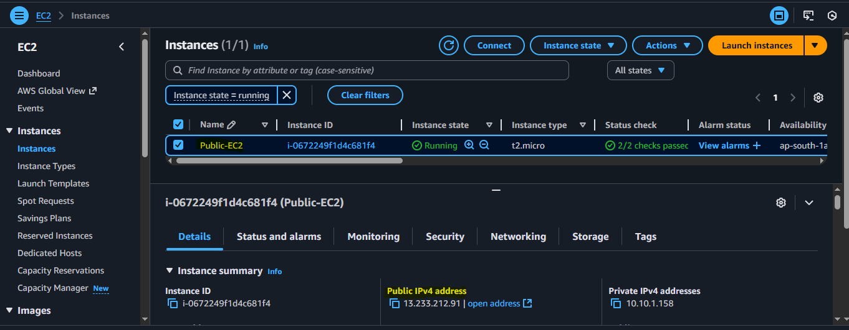

Linux EC2
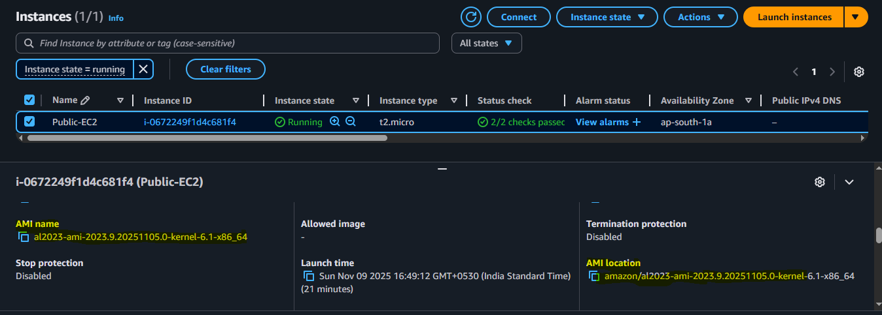

test-vpc and public subnet.
